**TC001 - Testing endpoint: Endpoint: /api/books**

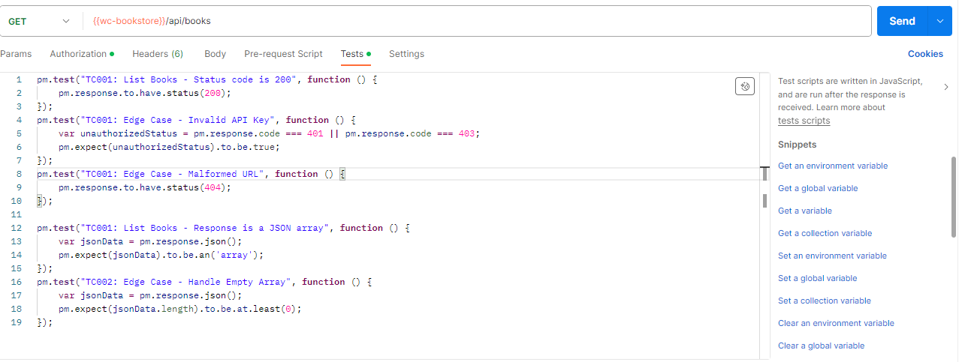

1. Send a request with valid credentials**: Test Passed**

Expectation : 200 OK response.

Results : The response was Valid with status code 200 OK

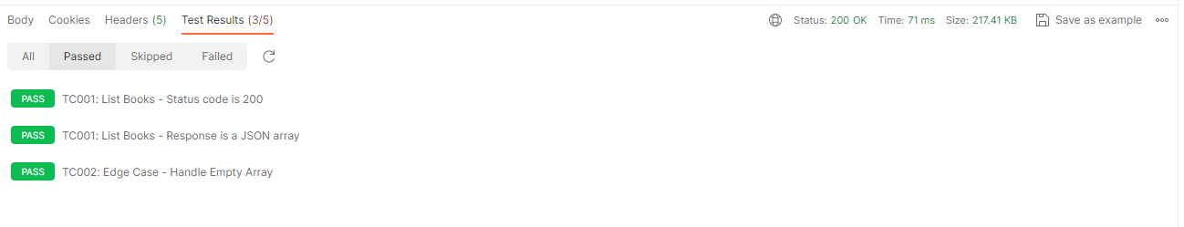

1. Send a request with invalid or no API key using this endpoint: **Test Passed**

Expectation - 401 Unauthorized.

Results:401 was returned when an invalid API key was supplied

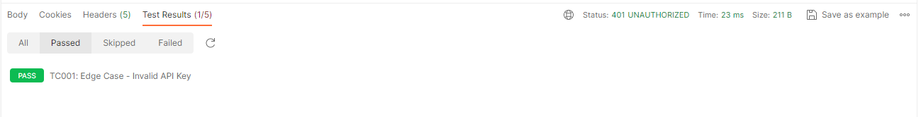

Send a request with a malformed URL for example <http://127.0.0.1:30002> in place of [http://127.0.0.1:3000](http://127.0.0.1:3000/) (changed port number)  
Expectation : 404 Not Found or similar error response

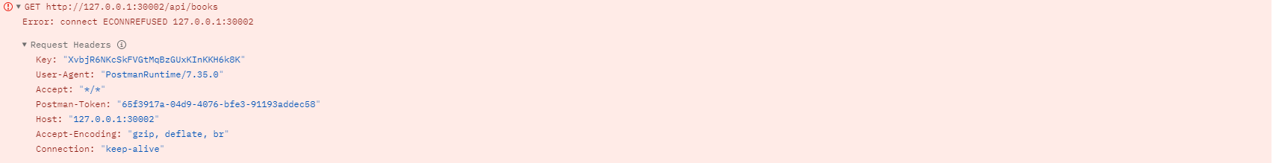

Send a request to the endpoint and check the json response

* + is it a valid response but with an empty JSON response?
  + Does the Json Response contain data?

Results: The array was returned with data in a valid format.

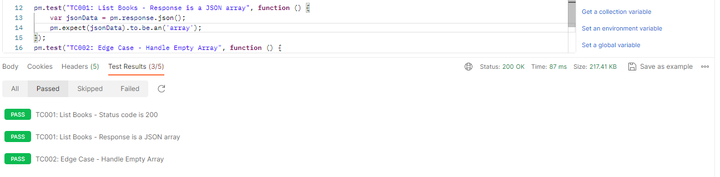

**TC002: Testing Endpoint supplied with** attribute**: /api/books?attribute=published_year&value=2007**

1. Send a request with specific query parameters e.g.` ?attribute=published_year&value=2007` **Test Passed**

    - we expect  200 OK response.

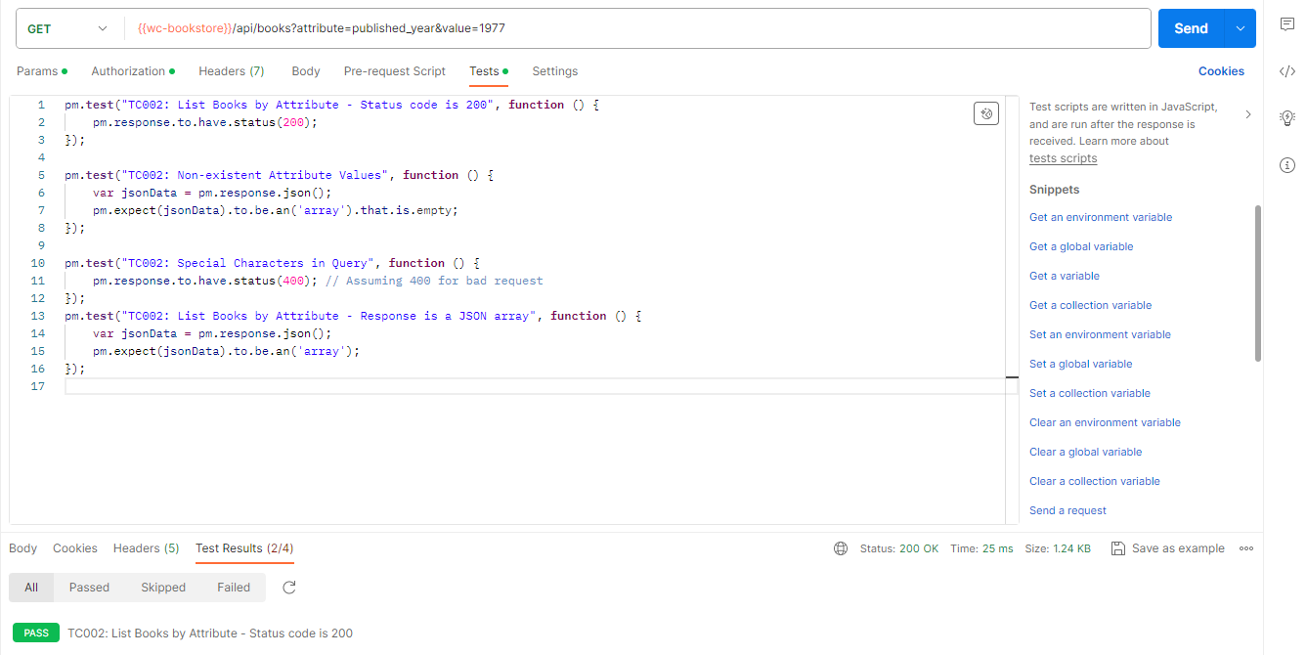

  2. Use non-existent attribute values (e.g., a future year) and expect a proper handling : **Test Passed**

   - Expectation: empty array

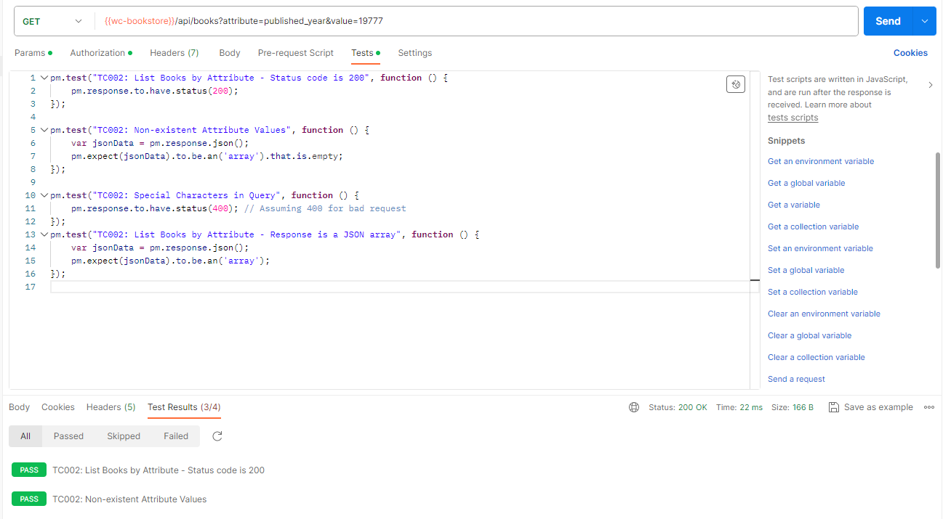

  3. Verify the API's response when the attribute filter matches no books

   - Expectation: empty array : **Test Passed**

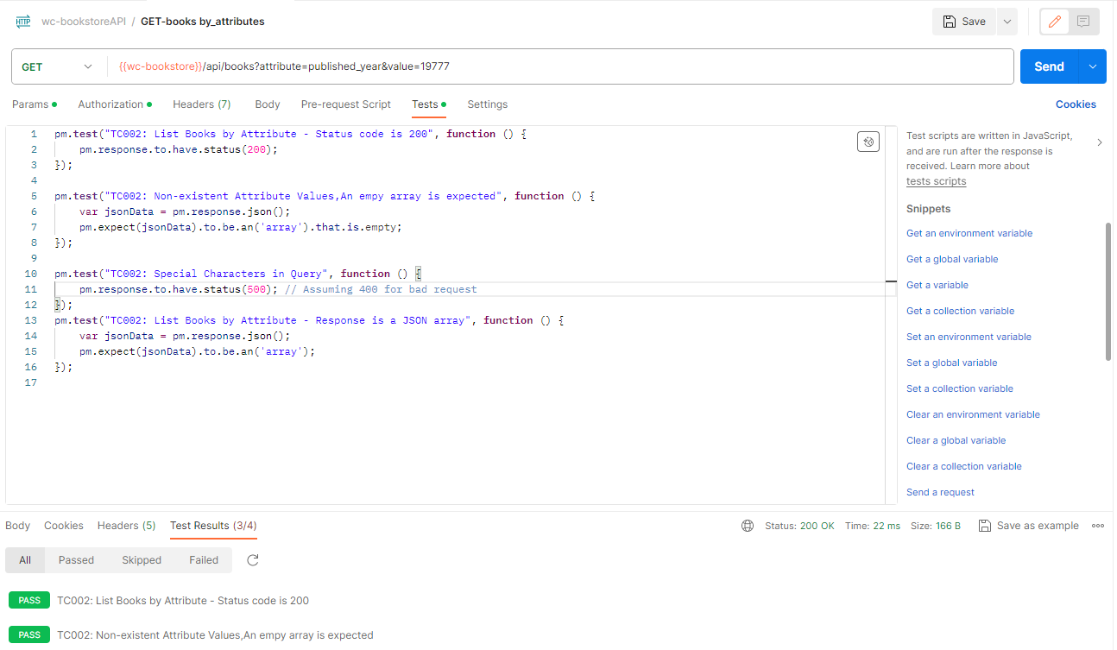

## TC003: Test Endpoint to Display single Book for /api/books/{isbn}

**## TC003: Test Endpoint to Display single Book :  `/api/books/{isbn}`**

  1. send a GET request for a single book: : **Test Passed**

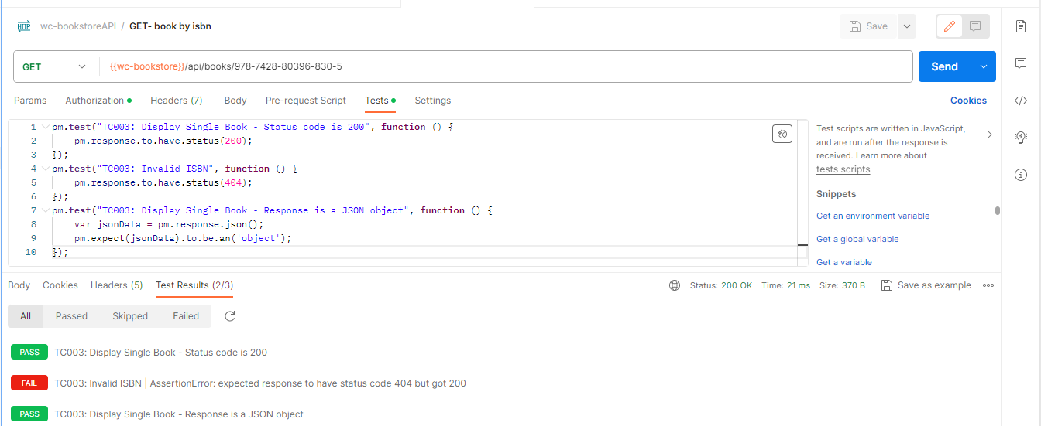

  2. Use an invalid or non-existent ISBN and expect a 404 Error : **Test Passed**

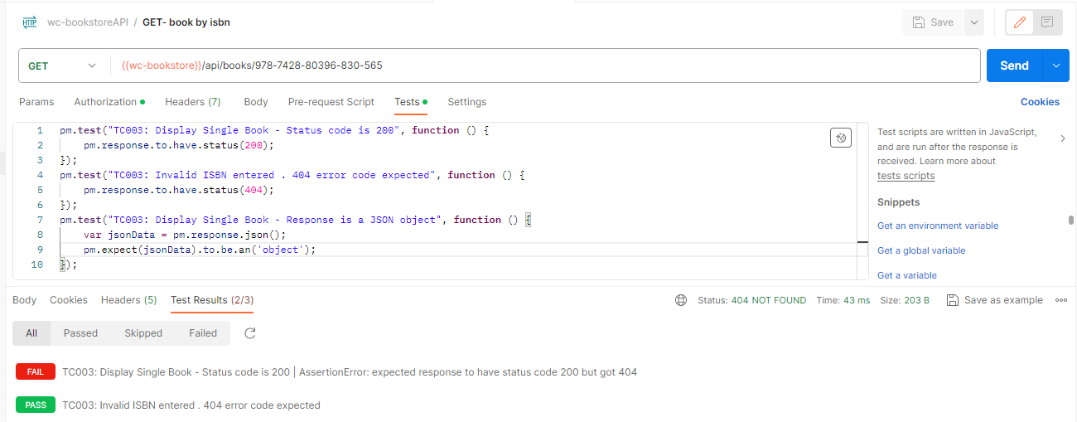

  3. Test with a malformed ISBN and check the response : **Test Passed**

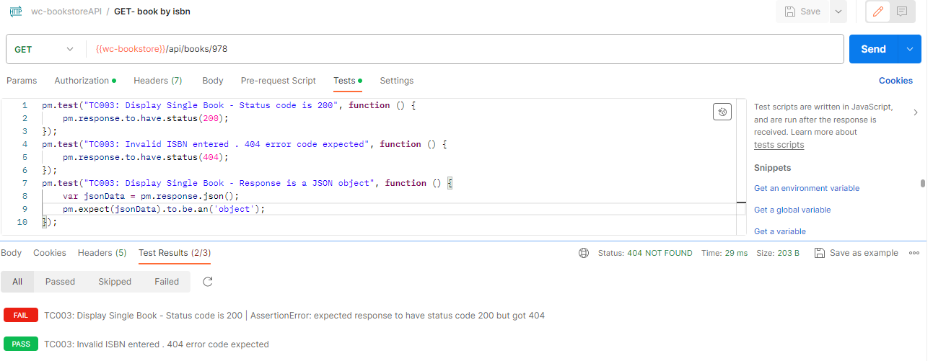

  4. end a request to the endpoint and check the json response : **Test Passed**

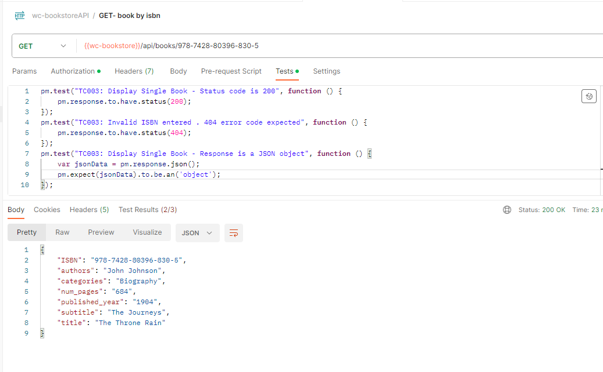

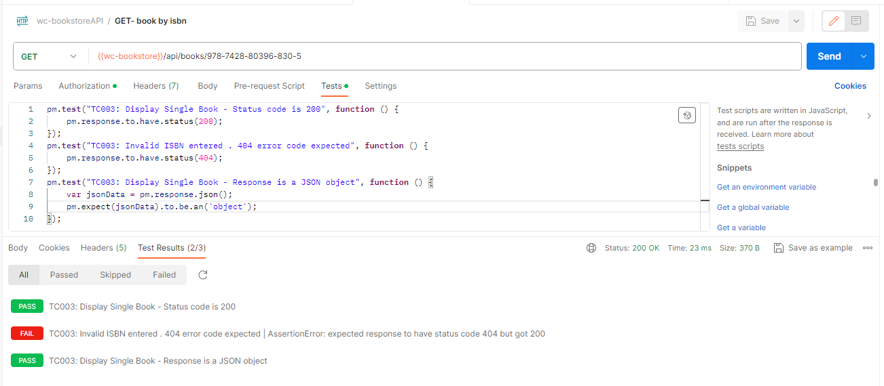

#### **TC004: Testing Endpoint : Add Book to Cart** **/api/{{userID}}/cart/add**

1. check for a 201 Created status after adding a book : **Test Passed**

    - Expected Results: 201 status code

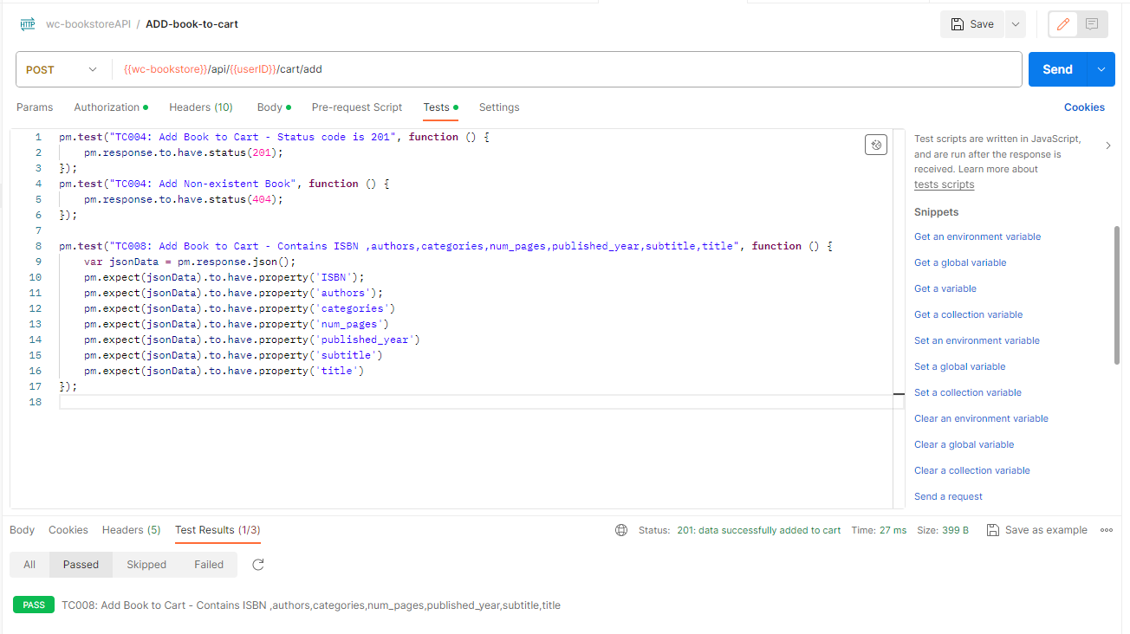

2. Confirm the presence of ISBN ,authors,categories,num_pages,published_year,subtitle,title in the response. : **Test Passed**

